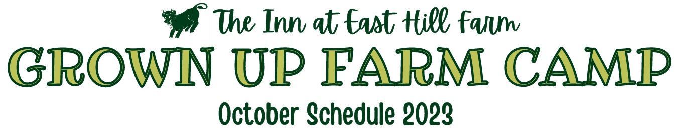
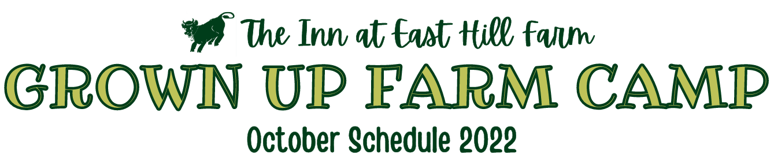

October Schedule 2026

Wednesday, October 21st
Sunday, October 18th
8:00 Breakfast
9:00 Milking in the barn
10:00 Qigong with Ginnette Groome in the small dining room
12:00 Lunch
2:00 Ice Cream Bar with Jen in the dining room
4:00 Meet by the covered wagon for a Farm Camp Photo
5:30 Cocktail Party in the dining room
6:00 Dinner
7:30 Covered Bridges of NH presentation with Kim Varney in the dining room
4:00 Cider & Donuts Welcome in the dining room
6:00 Dinner
7:30 Bingo in the dining room

Monday, October 19th
8:00 Breakfast
9:00 Milking in the barn
10:00 Needle Felting with Judy in the dining room
12:00 Lunch
2:00 Arts & Crafts in the dining room
4:00 Understanding Bobcats in NH presented by the NH Fish and Wildlife Stewards in the dining room
6:00 Dinner
7:30 Tune Trivia with Nicole in the dining room

Thursday, October 22nd
8:00 Breakfast
9:00 Milking in the barn
10:00 Field Trip to Frogg Brewing- meet by the mailbox at 9:30am to caravan- ($25 per person)
12:00 Lunch
2:00 Fika at the Fire with Jed
4:00 Keene, NH Walldog Mural Discussion with Gretchen Ziegler in the old living room
6:00 Dinner
7:30 LCR with Perri in the dining room

Tuesday, October 20th

8:00 Breakfast
9:00 Milking in the barn
10:00 Apple Cider Pressing meet by the barn
12:00 Lunch
2:00 Tractor-Drawn Wagon Ride to the “Magical” Pumpkin Patch meet by the barn
4:00 Nature Walk with Dan Bisaccio- meet by the mailbox
6:00 Dinner
7:30 Farmily Feud Trivia in the dining room

Friday, October 23rd

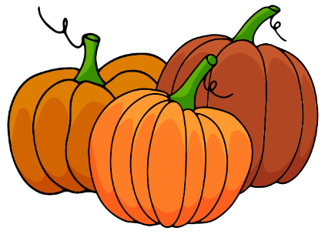
8:00 Breakfast
9:00 Milking in the barn
12:00 Lunch

